|  |  |  |  |  |  |
| --- | --- | --- | --- | --- | --- |
| **Ώρες** | **Δευτέρα** | **Τρίτη** | **Τετάρτη** | **Πέμπτη** | **Παρασκευή** |
| **1η** |  |  |  |  |  |
| **2η** |  |  |  |  |  |
| **3η** |  |  |  |  |  |
| **4η** |  |  |  |  |  |
| **5η** |  |  |  |  |  |
| **6η** |  |  |  |  |  |

****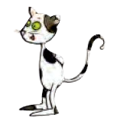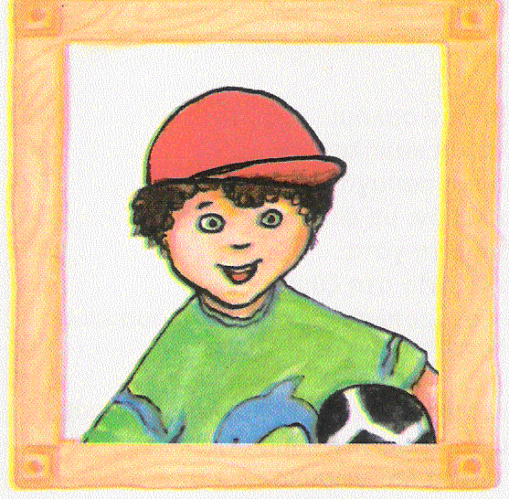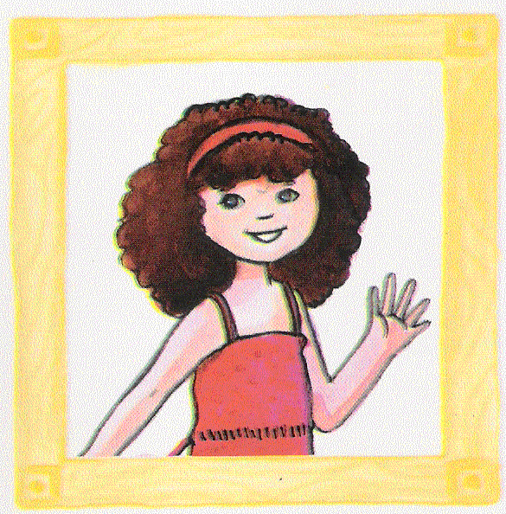 **ΠΡΟ** **ΓΡΑΜΜΑ ΜΑΘΗΜΑΤΩΝ Α΄ ΤΑΞΗΣ**

[https://ola-en-taxi.weebly.com](https://ola-en-taxi.weebly.com/pirhoomicrongammarhoalphamumualphataualpha-mualphathetaetamualphatauomeganu.html)

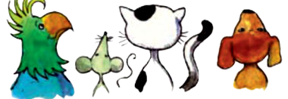****

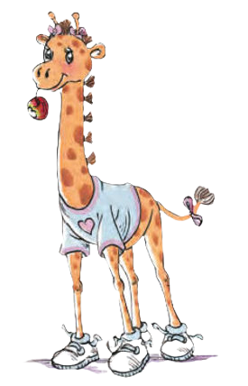****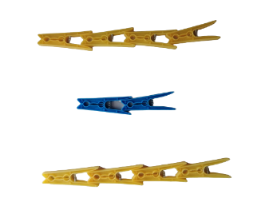********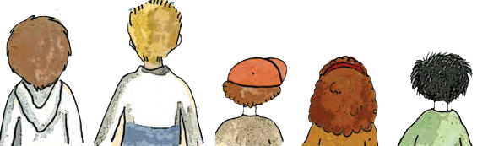

**ΠΡΟ** **ΓΡΑΜΜΑ ΜΑΘΗΜΑΤΩΝ**

΄

|  |  |  |  |  |  |
| --- | --- | --- | --- | --- | --- |
| **Ώρες** | **Δευτέρα** | **Τρίτη** | **Τετάρτη** | **Πέμπτη** | **Παρασκευή** |
| **1η** |  |  |  |  |  |
| **2η** |  |  |  |  |  |
| **3η** |  |  |  |  |  |
| **4η** |  |  |  |  |  |
| **5η** |  |  |  |  |  |
| **6η** |  |  |  |  |  |



[https://ola-en-taxi.weebly.com](https://ola-en-taxi.weebly.com/pirhoomicrongammarhoalphamumualphataualpha-mualphathetaetamualphatauomeganu.html)